**ASSIGNMENT 1**

TEAM ID:PNT2022TMID50609

Name : G SUBHASHINI

**Topic:**

**Home Appliances Automation Using** Arduino

**Circuit:**

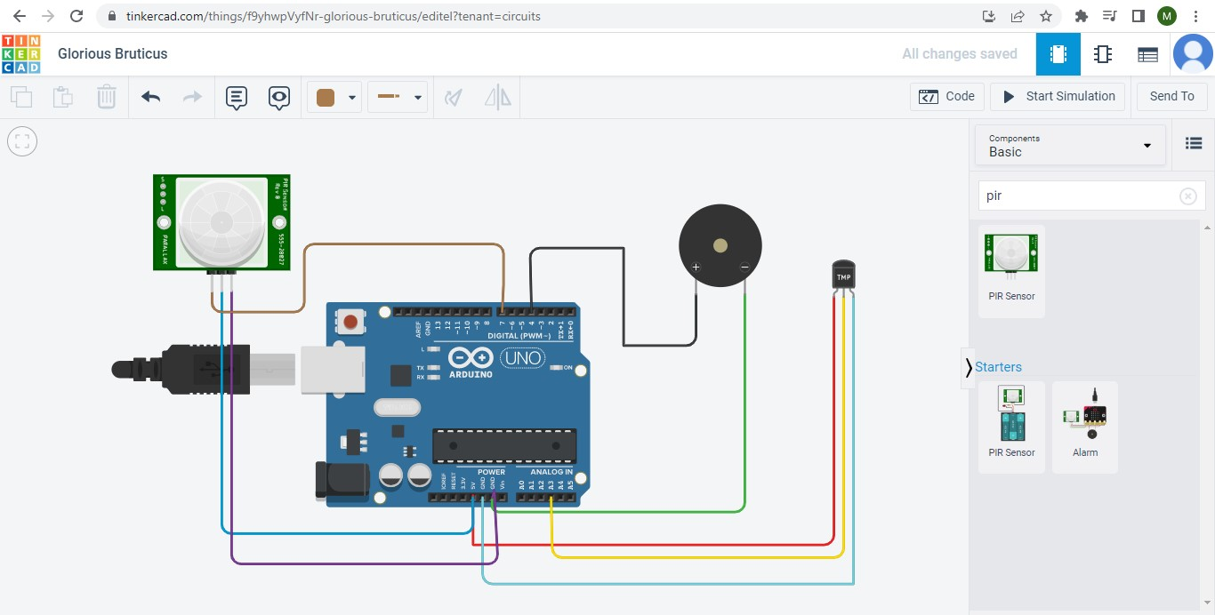

**Code:**

void setup()

{

Serial.begin(9600); pinMode(4,OUTPUT);

pinMode(7,INPUT);

}

void loop()

{

int mov=digitalRead(7); double dt=analogRead(A3); double n=dt/1024; double volt=n*5; double offset=volt-0.5; double temp=offset*100;

Serial.print("Temperature Detected: ");

Serial.println(temp); if(mov==0){

Serial.println("No Motion Detected");

}

if(mov==1){

Serial.println("Motion Detected"); tone(4,100,1000);

}

if(temp>60){

tone(4,400,1000);

}

}

**Output:**

